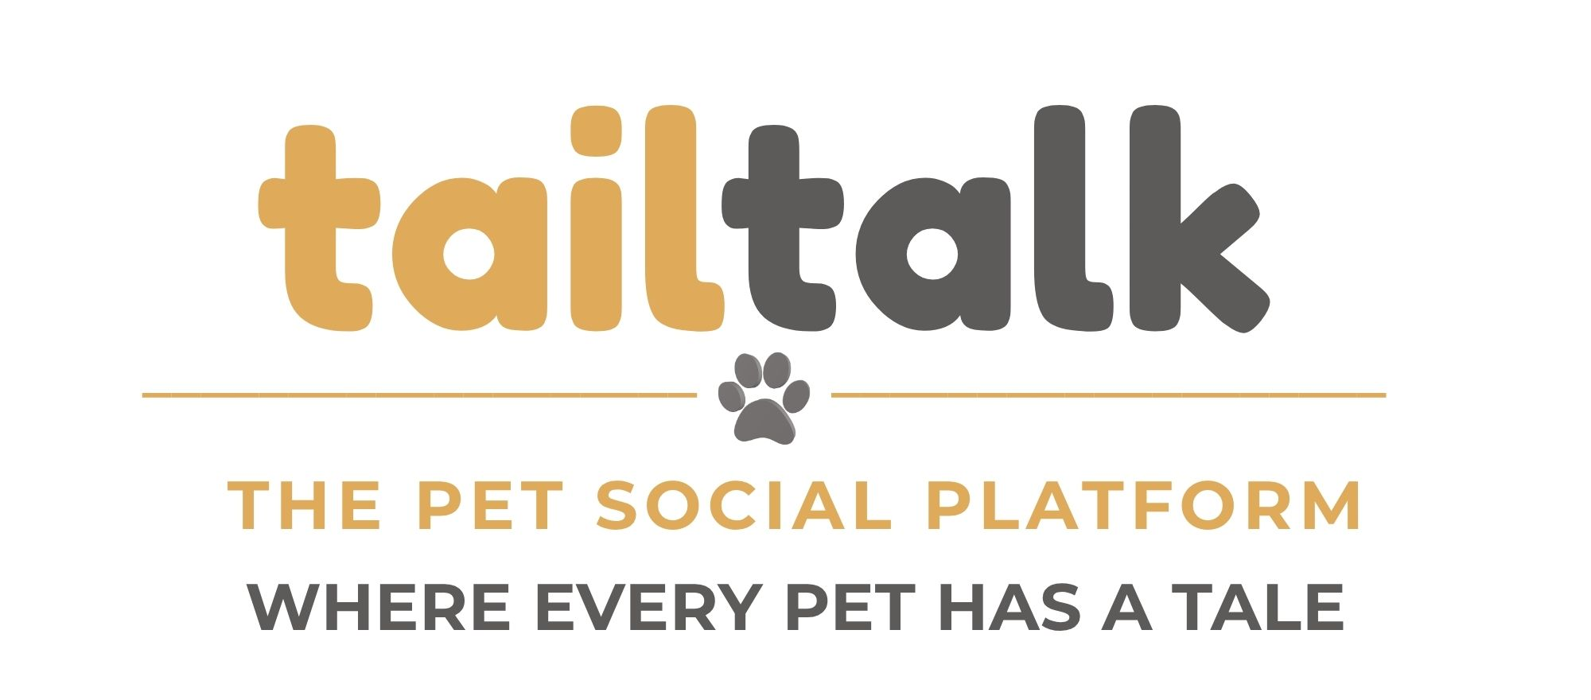

Phase 1 Launch Features

Product Philosophy
tailtalk should feel immediately familiar to anyone who has used Facebook or Instagram while making pets—not people—the center of the social experience.

Bottom Navigation - should remain visible/accessible throughout each step of the app
Navigation | Purpose
🏠 Home | Community-wide feed featuring public pet posts, communities, businesses, rescues, featured content, and future sponsored content.
🐾 PawPals | Personalized feed showing ONLY posts from pets followed by any of the owner's pets.
🚨 Pet Alerts  🔔 Notifications | Lost & Found hub with nearby alerts, maps, reporting, and emergency notifications.  All/any activity on our pet profiles (since owners can have multiple pets, every notification should clearly indicate which pet it's about:  Example: Cody - Daisy gave your post a paw. Ozzie- Cody commented on your post. Bella – your story received 15 paws.  Suggested pawpals (pets to follow), tailtalk messages, pet alerts, birthdays
💬 Tailtalks | Private messaging between pet owners.
👤 Owner | Owner dashboard with profile photo, My Pets, account settings, and profile management.

Home Feed
Purpose: Discover what's happening across the entire Tailtalk community.
- Stories displayed across the top
- 'What's your pet up to today?' composer below Stories
- Public pet posts
- Communities/Groups
- Business posts
- Rescue organization posts
- Featured & Trending content
- Tailtalk announcements
- Sponsored content (future)

PawPals Feed
Purpose: Display a personalized feed from pets your pets are connected with.
- Stories displayed across the top
- 'What's your pet up to today?' (composer…create a post, upload video, create reel)
- Feed combines posts from every pet followed by ALL of the owner’s pets.
- Like
- Comment
- Share
- Follow
- Report content
- No business posts
- No community posts
- No sponsored content
- Designed to keep owners connected to their pets' social circles

Pet Alerts
- View nearby lost pets (25 mile radius)
- Create a Lost Pet Alert (25 mile radius)
- Interactive map with last known location
- Contact owner
- Mark pet as found
- Emergency notifications

Tailtalks
- Inbox
- Private conversations
- Photo sharing
- Search conversations

Owner Dashboard
- Owner profile picture shown in bottom navigation
- My Pets
- Add New Pet
- Tap a pet to view/edit its public profile
- Edit Owner Profile
- Settings
- Privacy
- Notification Settings
- Log Out

Pet Profile
- Pet profile photo
- Pet details (species [free text], breed [free text], birthday, bio, location)
- Followers
- Following
- Posts
- Stories
- Follow
- Message Owner
- Share Profile
- Copy Profile Link
- Edit Profile

Posting & Sharing
Posts are created from the Home composer. Every public post includes timestamp it was posted, ability to Like, Comment, Share and More. Public pet profiles include Share Profile and Copy Profile Link.

Maybe use these emojis for reactions:
🐾 Paw (for like) ❤️ Love Comfort 💬 Comment 🔄 Share

APP HIERARCHY (Phase 1)
Launch App
│
├── Log In
│
├── Create Account
│ │
│ ├── Owner Profile
│ │ ├── Owner Photo
│ │ ├── Name
│ │ ├── Username
│ │ ├── Email
│ │ └── Password
│ │
│ └── Create First Pet
│ ├── Pet Photo
│ ├── Pet Name
│ ├── Species
│ ├── Breed
│ ├── Birthday
│ ├── Gender
│ ├── Bio
│ └── Save
│
└── Enter App

🏠 HOME
Home
│
├── Stories
│ ├── View Story
│ └── Create Story
│
├── "What's your pet up to today?"
│ ├── Photo
│ ├── Caption
│ ├── Tag Pets
│ ├── Tag Businesses
│ └── Publish
│
├── Community Feed
│ ├── Public Pet Posts
│ ├── Business Posts
│ ├── Community Posts
│ ├── Rescue Posts
│ ├── Featured Posts
│ └── Sponsored Posts (future)
│
└── Each Post
├── Paw
├── Love
├── Comment
├── Share
├── More (...)
└── Open Pet Profile

🐾 PAWPALS
PawPals
│
├── Cody
│ ├── Followers
│ ├── Following
│ └── Feed
│
├── Bella
│ ├── Followers
│ ├── Following
│ └── Feed
│
├── Ozzie
│ ├── Followers
│ ├── Following
│ └── Feed
│
└── Suggested PawPals

Maybe the main PawPals screen could also have a toggle:
Combined Feed or Browse by Pet

🚨 PET ALERTS
Pet Alerts
│
├── Lost Pets Near Me (25 mile radius)
│
├── Search Lost Pets
│
├── Create Alert
│ ├── Photo
│ ├── Pet name
│ ├── Description
│ ├── Last seen (maybe include map)
│ └── Submit
│
├──
│
└── My Alerts (alerts that I/owner created)

💬 TAILTALKS
Tailtalks
│
├── Inbox (with search bar at the top, ability to search by owner or pet to start a conversation)
│
├── Conversations (with writing pen icon)
│ ├── Photos/video
│ ├── Emoji (ablilty to quick-reply to a conversation with the same emoji’s offered for posts)
│ └── Report (if you think we need this option)
│
└── Start a tailtalk (to create a message)

👤 OWNER (pulls in the profile photo, if added)
Owner
│
├── Owner Profile
│
├── My Pets
│ │
│ ├── Cody
│ │ ├── View Profile
│ │ ├── Edit Profile
│ │ ├── Followers
│ │ ├── Following
│ │ ├── Posts
│ │ ├── Stories
│ │ ├── Share Profile
│ │ └── Copy Link
│ │
│ ├── Bella
│ │
│ ├── Ozzie
│ │
│ └── Add New Pet
│
├── Settings
│
├── Privacy
│
├── Notifications
│
└── Log Out

🐶 PET PROFILE (all profiles are public. I don’t think we need the option to make them private)
Pet Profile
│
├── Cover Photo
│
├── Profile Photo
│
├── Bio
│
├── Followers
│
├── Following
│
├── Posts
│
├── Stories
│
├── Reactions
│
├── Follow
│
├── Message Owner
│
├── Share Profile
│
└── Copy Profile Link

Business Profiles –
- Profile Image
- Business Name
- Category
- Hours
- Website field
- Phone# field
- Directions
- Message
- Follow

